

**LAB REPORT**

SIMULATION & MODELING



**International College**

BSc. CSIT

5th Semester

**Submitted by: Submitted to:**

**Bipin Saud Sahodar Dhungana**

Roll no : 11 Lecturer



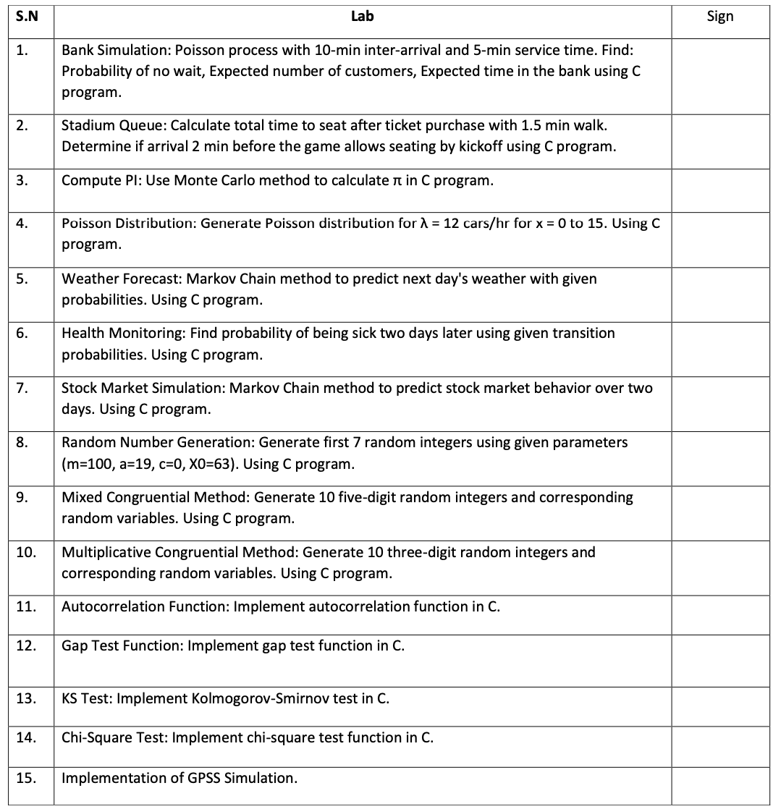

OUTPUTS

Lab-1

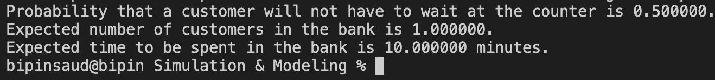

Lab-2



Lab-3



Lab-4

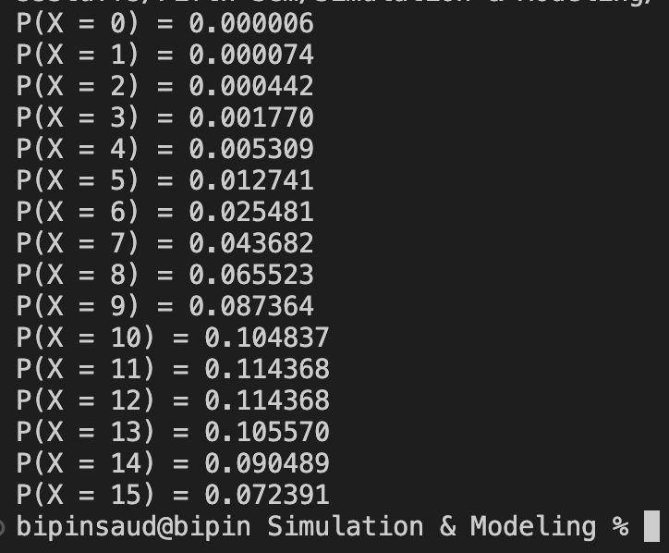

Lab-5

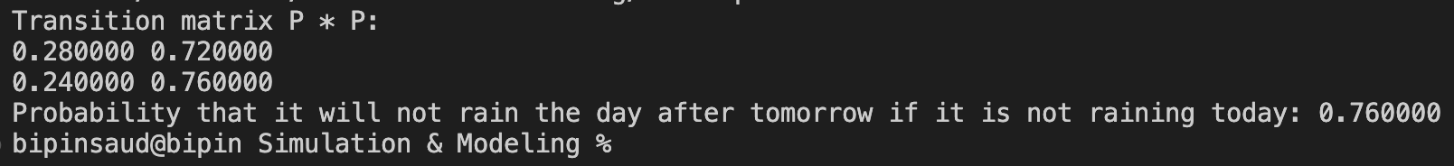

Lab-6

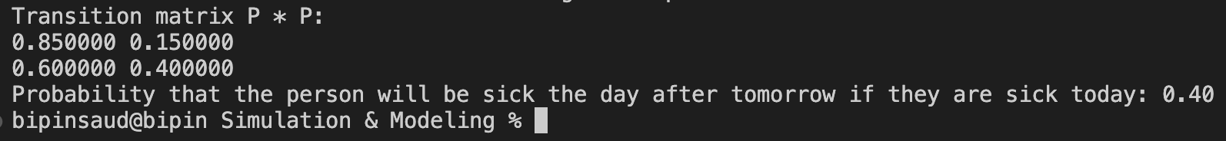

Lab-7

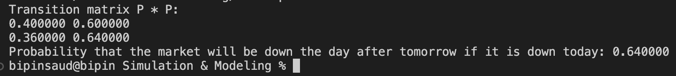

Lab-8

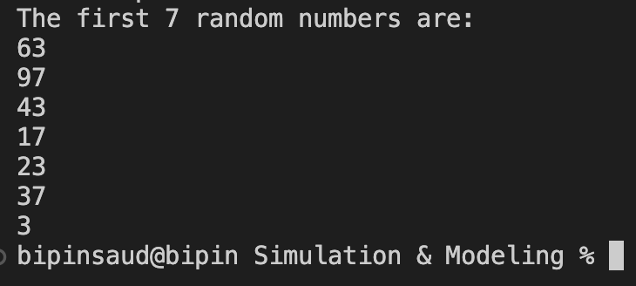

Lab-9

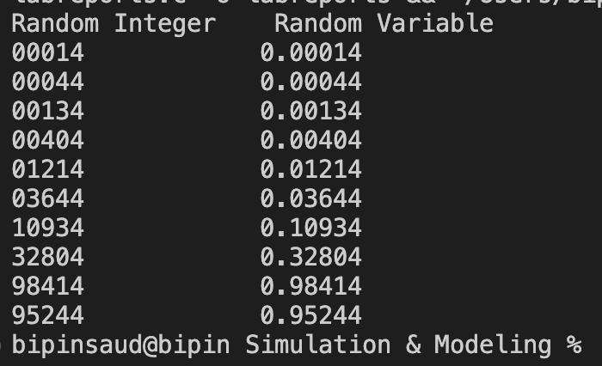

Lab-10

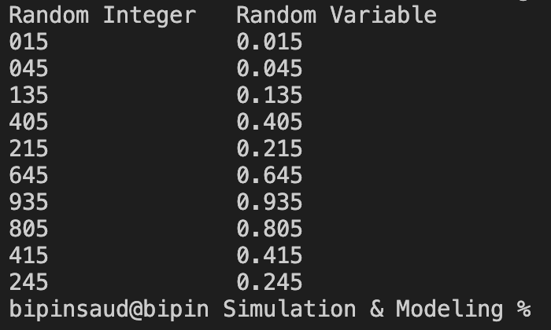

Lab-11

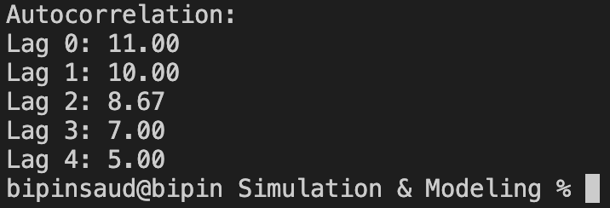

Lab-12

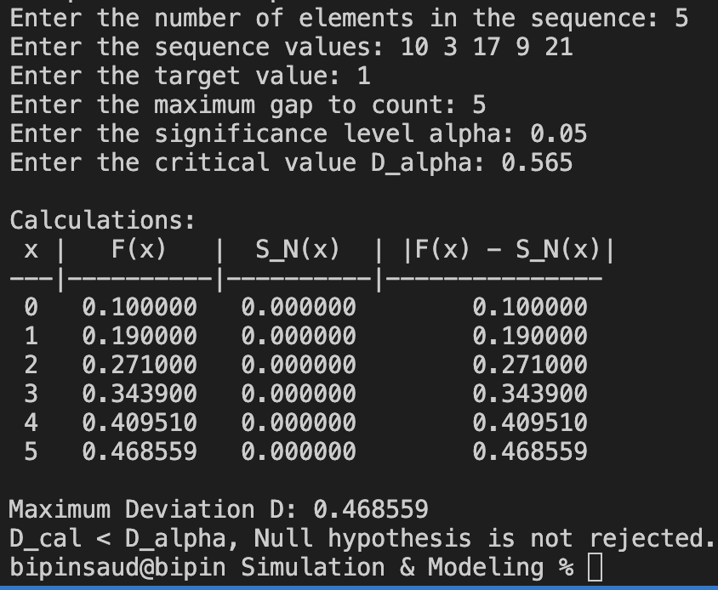

Lab-13

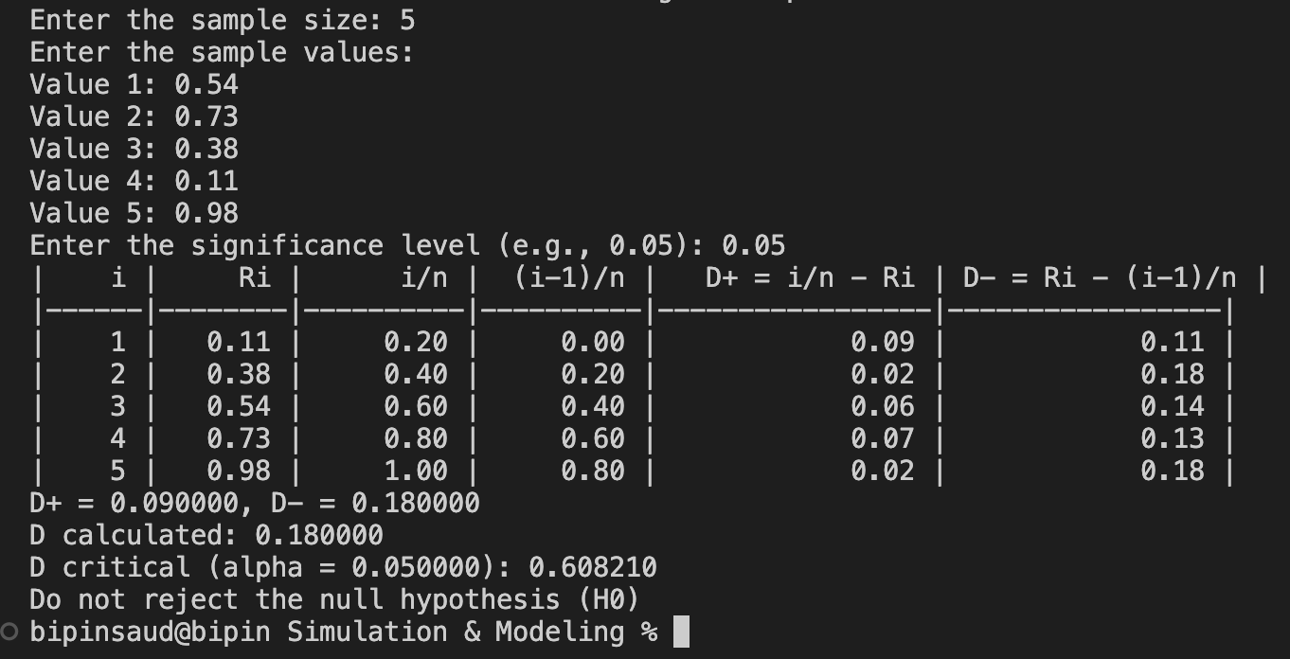

Lab-14

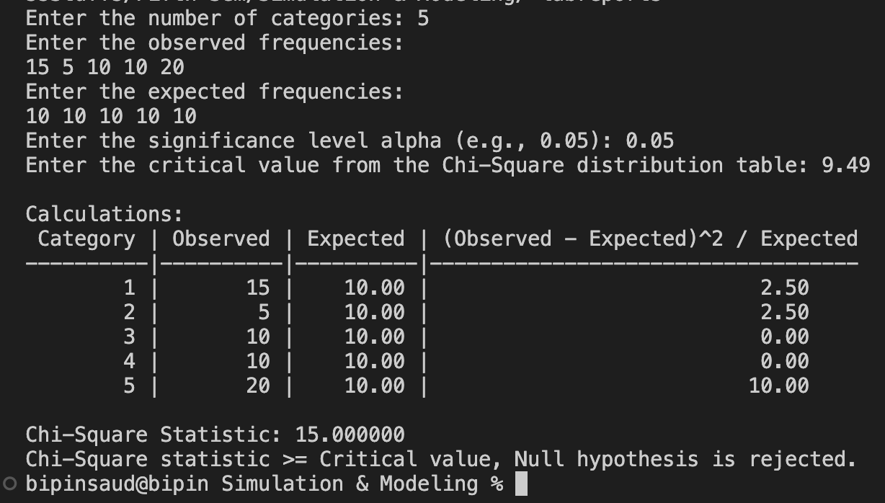

LAB-15

**GPSS MODEL**

**OBJECTIVE-1** :

Create a gpss model and program to simulate a barber shop for a day (9am to 4pm), where a costumer enters the shop every 10 ± 2 minute and a barber takes 13 ± 2 for a haircut.

**PROGRAM:**

GENERATE 10,2

QUEUE SEAT

SEIZE BARBER

DEPART SEAT

ADVANCE 13,2

RELEASE BARBER

TERMINATE

TIMER GENERATE 420

TERMINATE 1

**OUTPUT:**

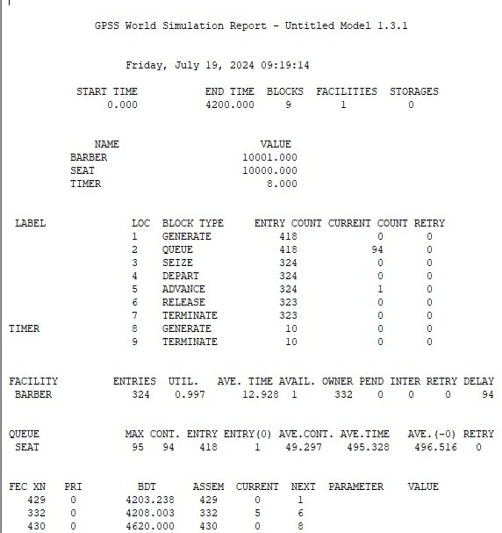

**OBJECTIVE-2** :

A machine tool in a manufacturing shop is turning out parts at the rate of every 5 minutes. When they are finished, the parts are sent to an inspector, who takes 4±3 minutes to examine each one and rejects 15% of the parts. Draw and explain a block diagram and write a GPSS program to simulate using the concept of facility.

**PROGRAM:**

GENERATE 5,0

QUEUE 1

SEIZE 1

DEPART 1

ADVANCE 4,3

RELEASE 1

TRANSFER 0.15 ACC REJ

ACC TERMINATE 1

REJ TERMINATE 1

**OUTPUT:**

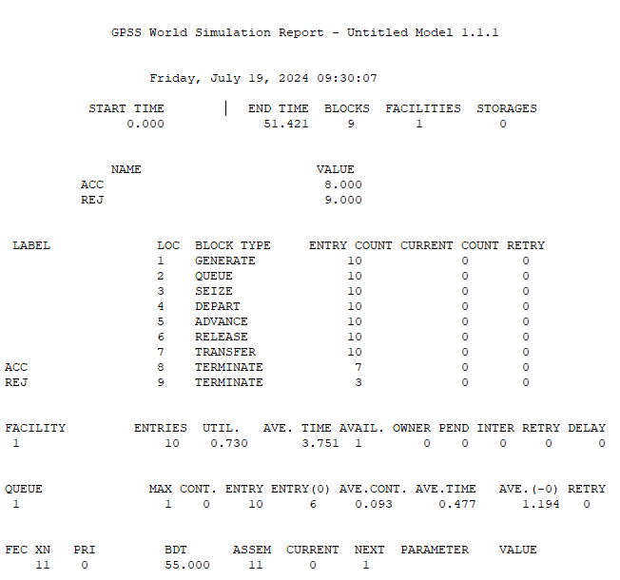

**OBJECTIVE-3**:

A machine tool in a manufacturing shop is turning out parts at the rate of every 5 minutes.

When they are finished, the parts are sent to an inspector, who takes 4±3 minutes to examine

each one and rejects 20% of the parts. Draw and explain a block diagram for it and write a

GPSS program to simulate using the concept of FACILITY.

**PROGRAM:**

GENERATE 5,0

QUEUE 1

SEIZE 1

DEPART 1

ADVANCE 4,3

RELEASE 1

TRANSFER 0.2 ACC REJ

ACC TERMINATE 1

**OUTPUT:**

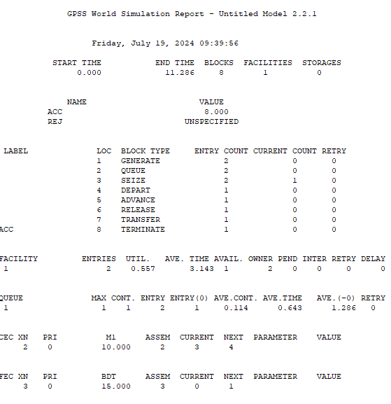

**OBJECTIVE-4**:

We are modeling a barber shop with the following qualities:

• The shop contains one barber and one barber’s chair, open for eight hours in a day.

• Customers arrive on average every 18 minutes, with the arrival time varying between 12

and 24 minutes.

• If the barber is busy, the customer will wait in a queue.

• Once the barber is free, the next customer will have a haircut.

• Each haircut takes between 12 and 18 minutes, with the average being 15 minutes.

• Once the haircut is done, the customer will leave the shop.

We want to answer these questions:

• How utilized is the barber through the day?

• How long does the queue get?

• On average, how long does a customer have to wait.

**PROGRAM:**

GENERATE 18,6

QUEUE 2

SEIZE 3

DEPART 2

ADVANCE 15,5

RELEASE 3

TERMINATE 0

GENERATE 480

TERMINATE 1

**OUTPUT:**

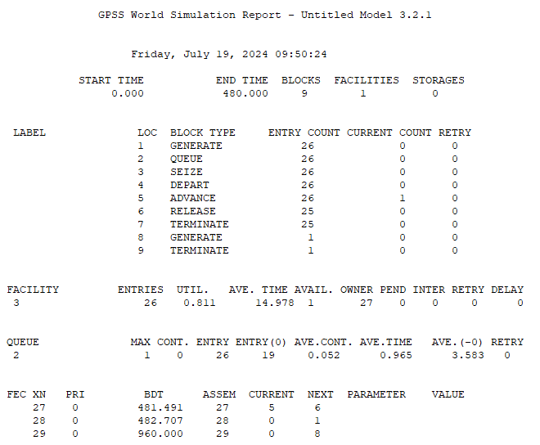

**OBJECTIVE-5**:

Consider that a machine tool in a manufacturing shop is turning out parts at the rate of one every 5 minutes. As they are finished, the parts go to an inspector, who takes 4±3 minutes to examine each one and rejects 10% of the parts. Now, develop a block diagram and write the code for simulating the above problem using GPSS, and also explain the function of each block used in the block diagram in detail.

**PROGRAM:**

GENERATE 5,0

QUEUE 1

SEIZE 1

DEPART 1

ADVANCE 4,3

RELEASE 1

TRANSFER 0.1 ACC REJ

ACC TERMINATE 1

REJ TERMINATE 1

**OUTPUT:**

